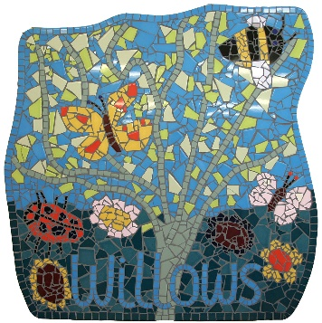
Stay and Play at The Willows
We are holding a term of Stay and Play sessions and would love to see you and your child.
We are offering different activities each session and staff will be on hand to answer any development questions you may have.
Come and play on Friday afternoons in September 2015, 1.30 – 2.30pm.
For more details contact Rach on 01225 769489 or email staffwillows@googlemail.com
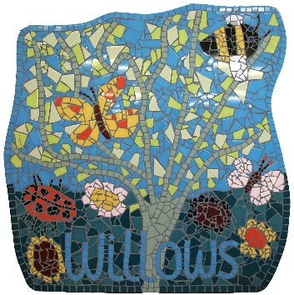

Stay and Play at The Willows
We are holding a term of Stay and Play sessions and would love to see you and your child.
We are offering different activities each session and staff will be on hand to answer any development questions you may have.
Come and play on Friday afternoons in September 2015, 1.30 – 2.30pm.
For more details contact Rach on 01225 769489 or email staffwillows@googlemail.com

