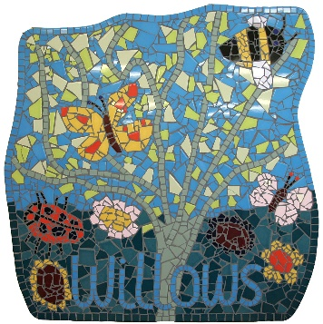
The Willows
January 2018
Hello! Thank you for all the thoughtful gifts and cards you sent our way for Christmas. We are starting to wear slippers when inside the classroom. This encourages independence for the children and also helps our floors to stay cleaner! Please support us by bringing (named) slippers in for your children to wear.

We welcome Frances our new member of staff. Frances will be covering Lou’s maternity leave. She has lots of experience in early years and we are looking forward to working with her.

An update on our targets: we have been recycling all items possible, and continue to feed the birds! Over Chrsitmas we have ensured that the children create their own gifts, cards and other crafty activities. We also reduced the amount of adult led focus throughout the Nativity to allow more imaginative input. Our Wider World wall needs much more input from our families – photos of holidays, families and events you take part in would be grately received.

We offer an early start option which you can book at any point. We open at 8.30am for parents wishing to use this service. Please let me know if you require it.

Your child’s keyperson should be your first point of contact; however, all staff are happy to try and help with any questions, concerns or comments. Please feel able to approach staff regarding anything you’d like support with or speak to Rach if you need further details.

If you would like to be added to the hot lunch email list then please let me know. Meals are bookable each month and cost £2.30 per meal. There is an admin fee of £5 for any late orders.

PE sessions take place on a Mon and Tues morning. Children starting school next September will attend these sessions. They don’t need PE kits until later in the year.

Please check your child’s drawer on a regular basis. We use this to put invoices, letters, mail, drawings and belongings in. We also ask that you name EVERYTHING that your child brings with them. This includes drink bottles!!

Could parents please keep their children with them when waiting outside the preschool. We also ask that you prevent them from fiddling/removing anything from the foyer.

We have some committee meetings coming up – keep an eye on Facebook for more info. You can then have a say in our social events, our fundraising and our activities.

We are holding a sponsored scavenger hunt at the end of the month. Children will be given a paper bag and a sponsorship form, and sponsored to collect particular items on their way to and from preschool. Please support us in this fundraiser.

Term three ends on Friday 9th February.
We will return on Monday 19th February.
We are planning parents’ evening/sessions at the end of February/beginning of March – keep an eye on facebook or in the foyer for more details.
Please find us on Facebook for even more info!

